Assignment -2

Mount Storage

1. Check disk storage

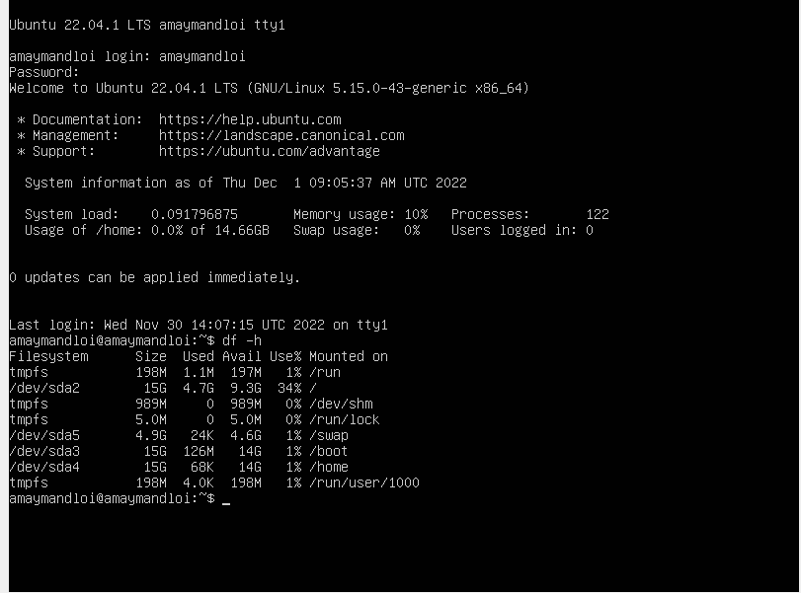

1. Sudo mkfs -t ext4/dev/sdb for add new drive.

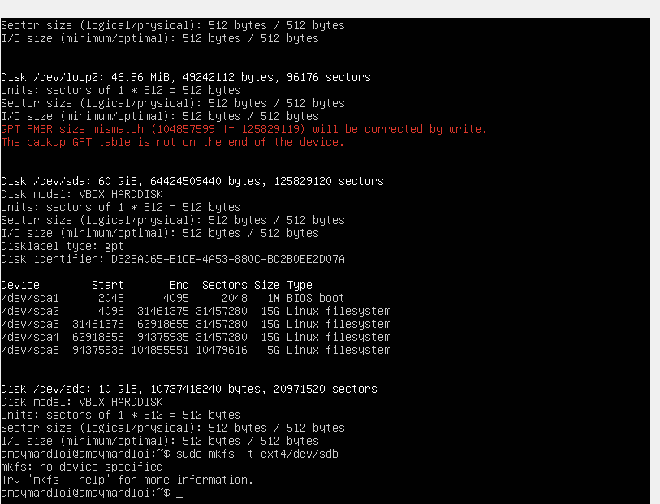

3 sudo mount /dev/sdb for Mount

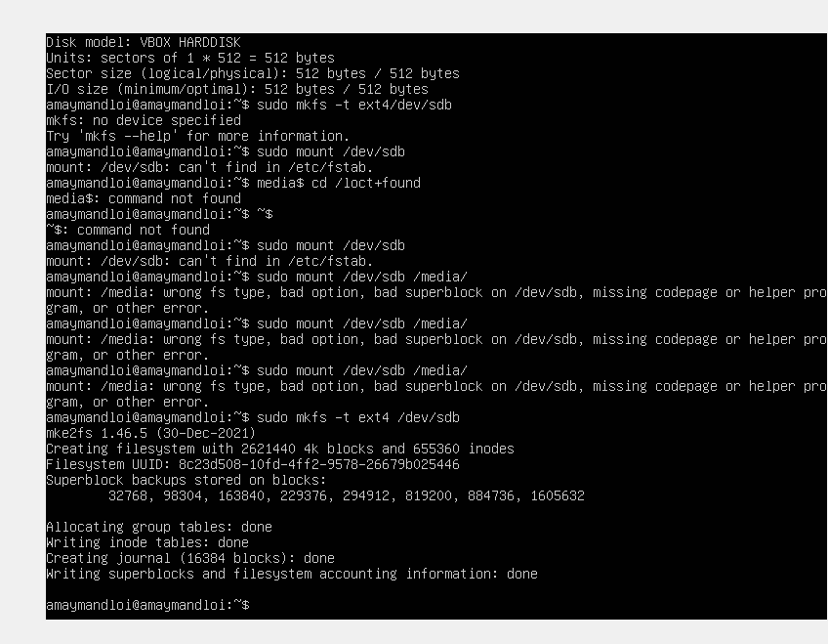

1. Sudo mount /dev/sdb /media create file media.

Cd/media

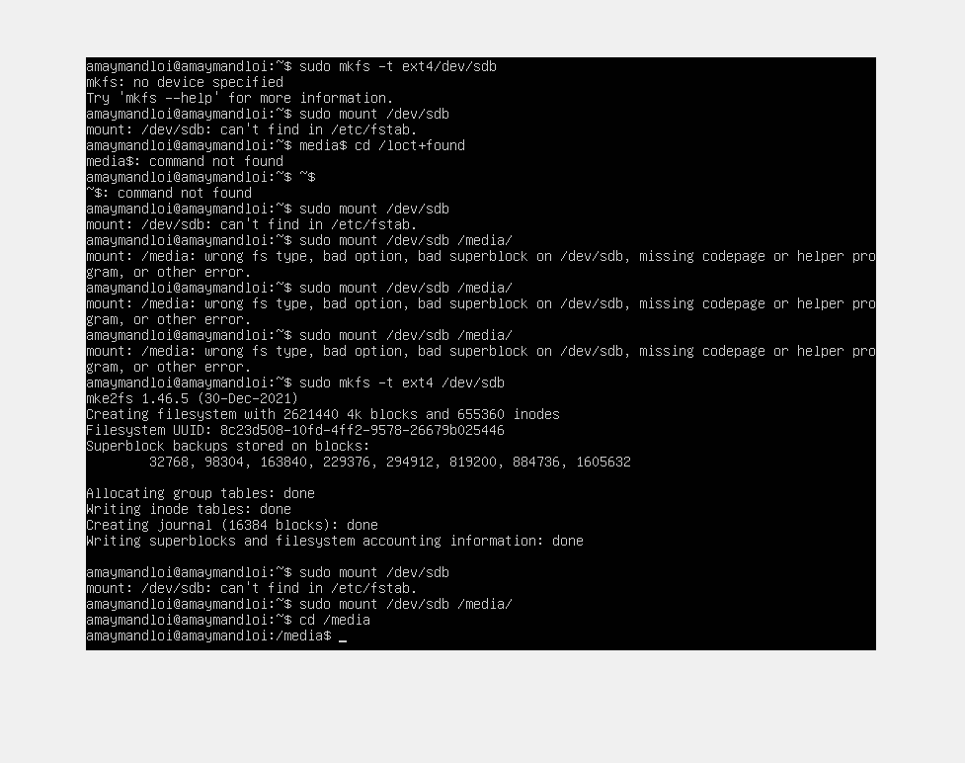

1. Again df-h

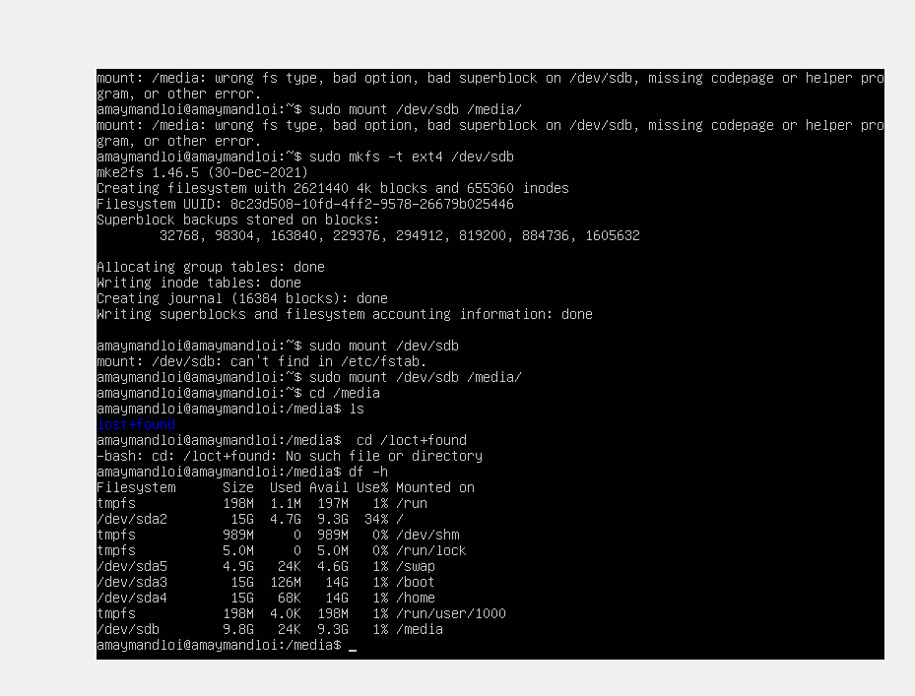

SSh Key Generation

Print Lsb

1. lsb_release -a , ssh-keygen

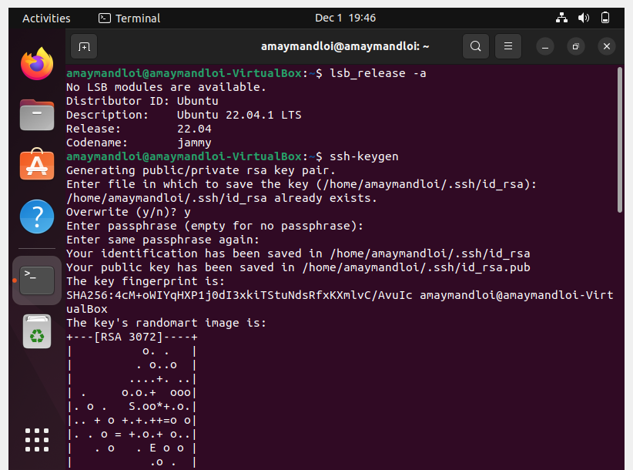

2.cd .ssh , cat id_rsa.pub Create for new authentication

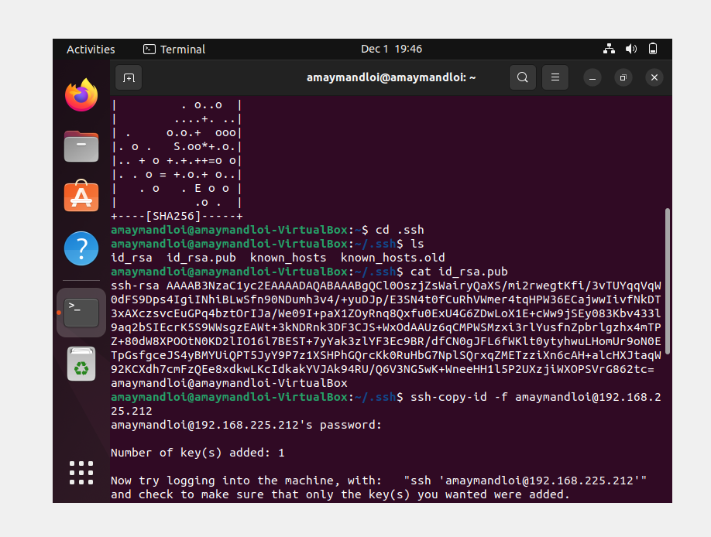

3.lsb_release -a , sudo apt install openssh-server Print certain Lsb and Install ssh

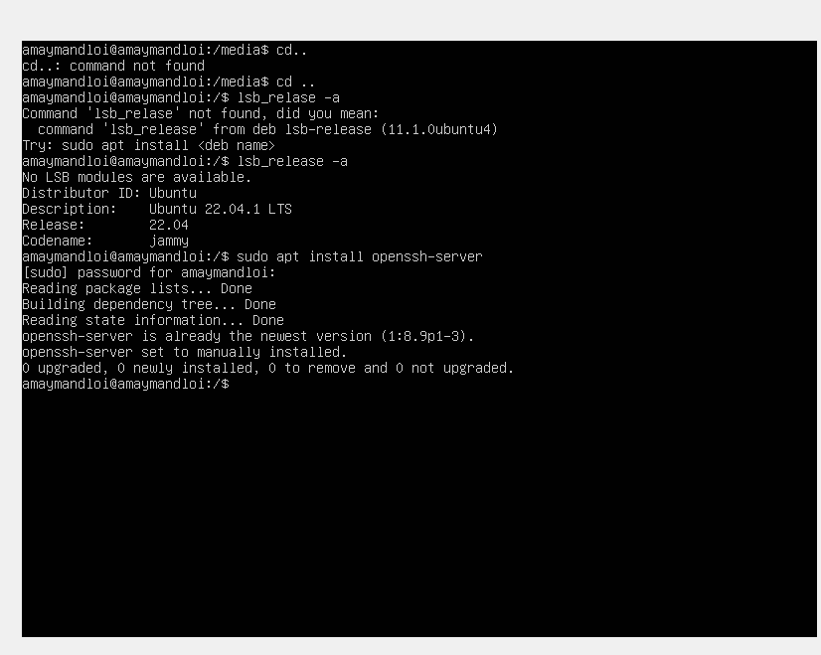

4.

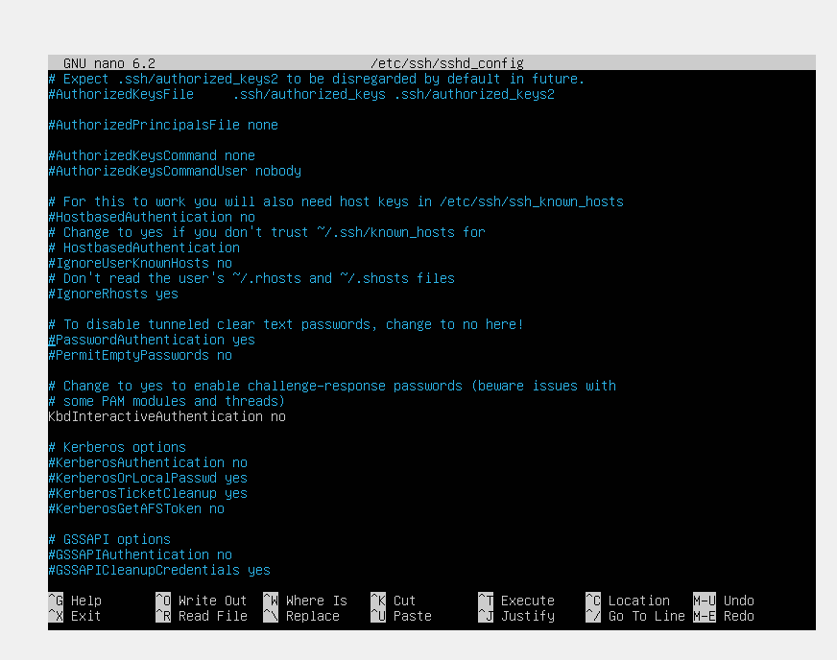

5.sudo service ssh restart

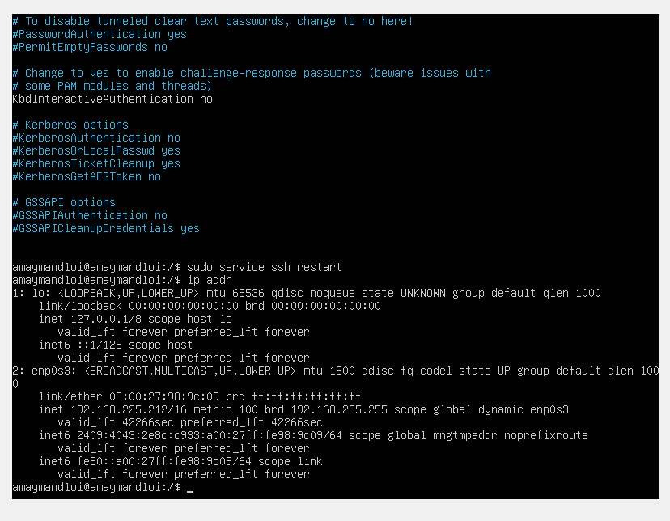

6. ssh-copy-id -f User@IP

